Decomposition and Conflict Resolution for Resource Allocation

Nimit Mehta

Introduction
Scheduling and resource allocation are related tasks. The problems are to assign one resource to one task such that no resource is allocated to more than one task at some time.
There are several approaches to resource allocation problems. Thus the decomposition heuristic and conflict resolution for resource allocation explained in “A Decomposition Heuristic for Resource Allocation” – Berthe Y. Choueiry and Boi Faltings was implemented and the procedure for decomposition was examined.

Problem Definition
A constraint graph is associated with the CSP where nodes (variables) represent the tasks to be executed, labels (domains) are the resource sets, and arcs (constraints) link nodes that intersect in time and have at least one resource in common.

Problem Decomposition Heuristic
The decomposition heuristic Value-Assignment Delay heuristic (VAD), operated on constraint graphs. In resource allocation problems many resources are solicited by many tasks at the same time and the constraints graphs tend to be densely connected. The intuition behind the VAD heuristic is to limit the high degree of interdependency among tasks by hiding the shared resources. This operation when applied repeatedly to the most solicited values will result in progressive elimination of arcs in the constraint graph, gradually separating it into independent clusters. The VAD can be briefly summarized as follows Delay the assignment of the most solicited values and try solving the simplified problem without them. Finally, distribute the delayed values to those variables that require them the most.
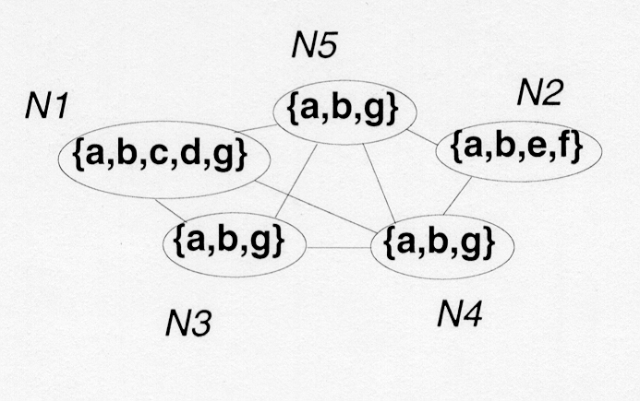
In the figure the constraint graph has five nodes N1, N2,…, N5 with their domains. The set of most solicited values is {a,b}. The VAD delays the assignment of these values. The values whose assignments are delayed are called delayed values. The initial network splits into two parts because N2 now shares no values with the rest of the graph. In cluster1, one can assign values e or f to N2 without hesitation and without further constraining the rest of the problem.
In cluster2 the four nodes are still competing values and each has as a reserve, a set of delayed values, d={a,b}. at the next step , {g} is delayed and unsolved cluster2 is split further into two parts cluster3 and cluster4. Again cluster3 is easy to solve sub problem. N1 in cluster3 can be assigned three nodes are left with an empty set of possible values. Each of these nodes reclaim the delayed values {a,b} and {g}.
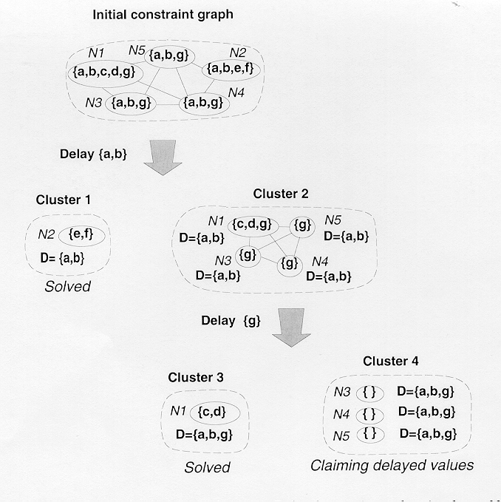

Resources are said to be upstream from a collection of tasks if they are on the path leading from these tasks to the root of the tree and tasks are said to be located downstream from a given set of delayed values if they belong to the subtree rooted at this set.
During the generation of the tree structure tests are carried out to decide whether a current sub problem should be refined further or not. These are two main reasons to stop decomposing a sub problem either it contains enough values to easily satisfy the needs of all its nodes, or decomposing it further would not discriminate among the needs of its nodes, In essence we try to keep the sub problem as coarse as possible, and we refine them only when this is really necessary. As a result the isolated leaves may contain sub problems of varying size. A clustering tree generated by such a strategy has an interesting feature, the number of its components is not fixed and their respective size is neither predefined nor constant. Thus the non-uniform distribution of difficulty in a problem is reflected faithfully in the corresponding tree structure.
Once the problem has been decomposed the sub problems in the leaves are solved using the conflict resolution.

Test Problem
The problem consisted of 25 operations with the domain for each operation and the starting time and ending time for each operation. The problem set was stored in a file and the program on execution would read this file and stores this information in the data structures. The main routine would then start by decomposing the problem. Once decomposition is done at any stage the new clusters are created due to decomposition are stored in a queue. So after each decomposition has been completed it would verify the status of the queue if the queue has more structures then the program would perform the decomposition on the cluster that is in the queue. This is repeated until there are no more clusters in the queue to decompose. At this point the program would then perform the conflict resolution foe each sub problem that was created by the decomposition. Once this has been done the program terminated.
The decomposition at each level starts of by displaying the cluster on which the decomposition is going to be performed. Then a test is performed to check if the cluster is a leaf cluster. If the cluster is the leaf cluster then no further decomposition is performed on the cluster. The cluster is not the leaf cluster then the program calls the routine that finds the set of resources that are still being competed for.
Once the set of resources that are being competed for are obtained, the set of variables that are competing for each particular resource are obtained. Once the set of variables that are competing for a particular resource has been obtained the contention curve (cc) for the resource is created. Before the contention curve can be created the start time and the stop time for the variables taken and then they are sorted in an increasing order of time. If two start time coincide at a particular point in time either could be placed before the other. If two stop times coincide at a particular point in time either could be place before the other. But if there are stop times and start times that coincide at a particular point in time them the stop time have to be placed before the start time. This sorting is performed for each resource that had variables that are competing for it.
Once the sorting has been performed the contention curve is then created. The contention curve is created for all the resources. The sorted time points are taken and each time point is given a value. Before assigning the time points values the variable value is given the value zero. Now going through the sorted time points if it encounters a start time then the variable value’s value is incremented by one and the value is assigned to the time point. If it encounters a stop time the variable value’s value is decremented by one and the value is assigned to the time point. Once all the time points for a resource have been assigned a value then the time points are verified for each time point that are a stop or start times only the last value at the stop or start time is taken the rest of the stop or start time are discarded. Also if two consecutive time points are equal the again only the last one is taken the rest are discarded.

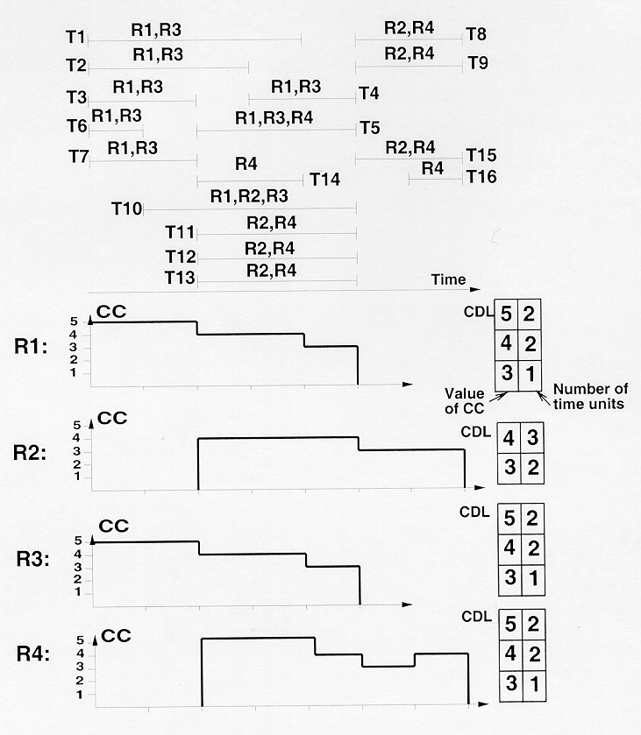

Once the contention curve has been created the cumulative demand list (cdl) is created. The cdl is created for each resource. The cdl is a two-element array that stores a value and also the time units. The values in the array are unique and in decreasing order. Adding the difference between the present value and the next value in the time points to the present time units of the value creates the time units for these values.
Once the cdl for all the resources have been created the resources. The most solicited values are calculated using the following criterion.
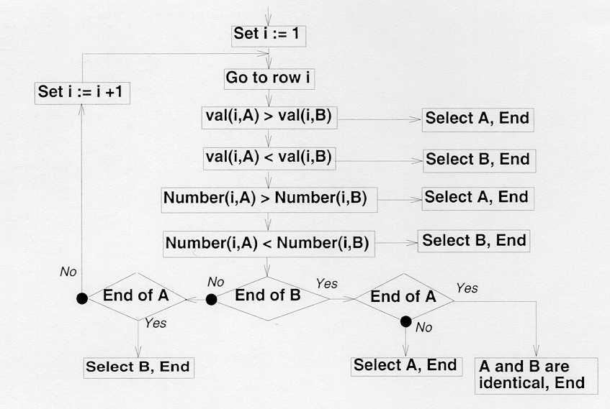
Now that the most solicited values have been obtained the present cluster is decomposed using the most solicited value and new clusters are created. The present cluster is taken and the most solicited values is removed from the present domain and placed in the delayed values domain. Then the constraints for the variables with the new domains are created. Then the variables are placed in an array. The first variable in the array is removed and the constraint graph with that variable is identified and made into a new cluster. This is done till there are no more variables in the array.
With the decomposition of the present cluster has been performed the present cluster is discarded and a new cluster is taken to decompose. This is repeated until there are no more clusters to decompose and the program has been created into sub problems.
Once the decomposition has been completed the program performs resource allocation. The leaves in the decomposition tree are obtained and the assignments are made to the variables. The leaf cluster is taken and then a check is made to verify if the problem is solvable. If the problem is solvable then a solution is searched. If the present cluster variables have no more resources from their present domain then a delayed values is taken to verify if it would not have any conflicts on allocation of the resource. This is repeated until all variables have been assigned.
Once all the clusters have been verified the program displays the results and the program terminates.

The Results
OP18 OP7 OP25 OP13 OP1 OP19 OP3 OP20 OP21 OP6 OP27 OP11 OP22 OP24 OP10 OP26 OP28 OP4 OP5 OP9 OP2 OP14 OP15 OP16 OP17
Initial constraint graph

Delay Mario
OP28
OP18 OP7 OP25 OP13 OP1 OP19 OP3 OP20 OP21 OP6 OP27 OP11 OP22 OP24 OP10 OP26 OP4 OP5 OP9 OP2 OP14 OP15 OP16 OP17

Delay Juan
OP18 OP5 OP9 OP2 OP16 OP19 OP1 OP3 OP10 OP6 OP20
OP11
OP17 OP7 OP4 OP14 OP15 OP13
OP22 OP27
OP26 OP21 OP24 OP25
Delay Mohamad
Sylvain
Sunthorn
OP4 OP14
OP15 OP13
OP17 OP7
Solvable
Unsolvable
Solvable
Solvable
Solvable

Unsolvable
Solvable

Conflict resolution failed because some sub problems were insolvable.

Conclusion
The program was successfully implemented as described in the paper “A decomposition heuristic for Resource Allocation” - – Berthe Y. Choueiry and Boi Faltings. A problem chosen and the decomposition of the problem was performed using the Value-Assignment Delay heuristic and the results were generated. More problems would have to decomposed and verified. An informed backtracking search could be implemented for conflict resolution.

